Week 5 – Report

25th March - 31st March

# Executive Report

So far we have sorted out good communication methods (Discord and in person) and a central location to store project documents (Onedrive). Not much work on the project has been completed yet so we will need to make sure we start bringing some content to the meetings to go through and discuss. I will need to keep communication with the group members to make sure they know what they’re doing and to make sure the work is being completed.

-Brad

# Progress & work tracking

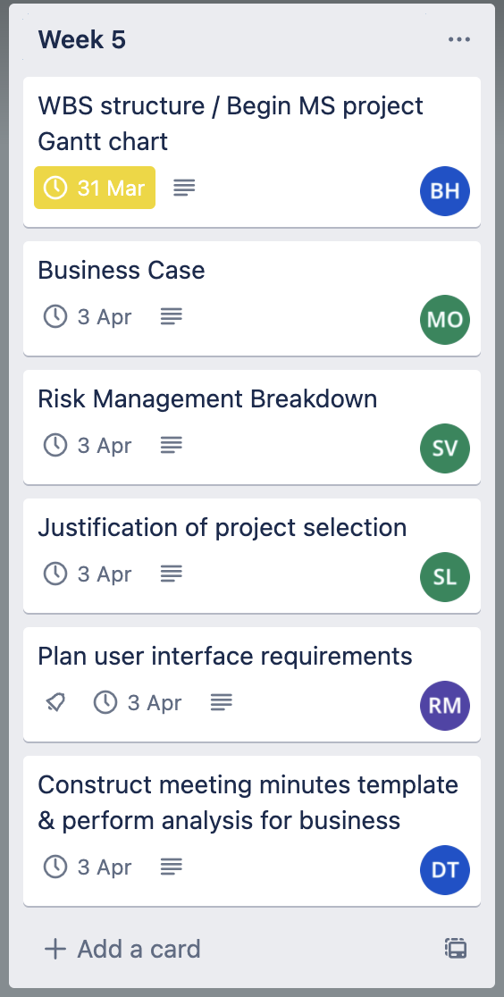

# Meeting minutes:

28/03/23 – 1 hour

|  |  |  |  |  |  |  |
| --- | --- | --- | --- | --- | --- | --- |
| **Member** | Bradley | Rhys | Mitch | Soham | Sourav | Huy |
| **Attendance**? |  |  |  |  |  |  |

31/03/23 – 15 minutes

|  |  |  |  |  |  |  |
| --- | --- | --- | --- | --- | --- | --- |
| **Member** | Bradley | Rhys | Mitch | Soham | Sourav | Huy |
| **Attendance**? |  |  |  |  |  | Sick |

Meeting times still being discussed, unattendance can be due to differing schedules.

# Meeting Minutes

Progress Report Summary

* Where each group member is up to with their allocated task.
* Quick questions about the tasks.
* Feedback on the work that has been completed.

Business Case discussion

* Discussion of existing business
  + Identifying the requirements
  + Costs and benefits
  + Feasibility of the project

Project scope

* Discussing scope of the project
* Discuss resources required for project.

New Task allocations

* Discuss what tasks you would like to do next or continue to complete.
* Group leader assigns tasks on Trello.

# Meeting discussion:

Progress Report Summary

* Everyone is understanding the idea and goals of the project; however work needs to be allocated to people so they know what they need to do.
* Group members happy to use Trello for work assignment and to track progress.

Business Case discussion

* Need to conduct further analysis on the business and create feasibility report and risk assessment.

Project scope

* All in agreeance to keep the system as simple as possible for the design to lay a foundation to work off.
* Focusing on a website for both desktop and mobile device is the goal, instead of having a separate mobile application.
* Gannt chat still under development for project scope

New Task allocations

* New tasks have been assigned to the different group members on Trello.
* Mitch is happy to focus on the business case
* Rhys is happy to focus on the front-end layout design and features
* Brad is going to focus on getting the MS project file set up (Adding project resources, work week, etc).

Random tasks have been assigned to members who